Visoka škola strukovnih studija za

informacione i komunikacione tehnologije

**Mobile Shop**

<https://tamarapav.github.io/MobileShop/>

Tamara Pavlović 175/18

Smer: Internet Tehnologije

Modul: Web programiranje

Predmet: Web programiranje 2

Contents

Uvod 3

Korišćeni programski jezici 3

Opis funkcionalnosti 3

Template 4

Organizacija 4

Organizaciona šema 4

Mapa sajta 4

Stranice 5

Index.html – Welcome I Najprodavaniji proizvodi 5

Index.html – Članovi tima, Brendovi, Rapair Service I Forma 6

Products.html – Prikaz proizvoda 7

Cart.html – Prikaz korpe 9

Aboutus.html – Informacije o članovima tima I komentari kupaca 10

Autor.html – Podaci o autoru 11

Kodovi 12

Index.html 12

Cart.html 19

Aboutus.html 22

Autor.html 25

style.css 28

Ispis.js 31

Main.js 39

Cart.js 41

Categories.json 43

Menu.json 45

Products.json 46

Crew.json 55

Comments.json 56

# Uvod

## Korišćeni programski jezici

Korišćena tehnologija, programski jezici:

* HTML, CSS3
* JavaScript, Jquery, Ajax, JSON
* FontAwesome font u ikonicama
* Bootstrap, Materialize

Za pisanje koda korišćen je Visual Studio Code.

## Opis funkcionalnosti

Sajt poseduje sledeće funkcionalnosti:

1. Dinamičko ispisivanje podataka iz JSON fajlova preko Ajax-a sledećih delova sajta:

* Meni na svakoj stranici
* Najprodavaniji proizvodi na Home stranici
* Članovi tima na Home I About Us stranici
* Spisak brendova koji se nalaze u shop-u na Home stranici I u formi
* Kategorije I proizvodi na Products stranici
* Komentari na About Us stranici

1. Filtriranje I sortiranje proizvoda po zadatim kriterijumima na Products stranici.
2. Dodavanje proizvoda u korpu I brisanje iz iste uz pomoć LocalStorage-a.

## Template

Template nije korišćen iz drugih izvora nego je samostalno pisan, stoga će to biti prikazano u sklopu koda na narednim stranicama.

# Organizacija

## Organizaciona šema

Sa svake stranice se može pristupiti svakoj stranici.

## Mapa sajta

<?xml version="1.0" encoding="UTF-8"?>

<urlset>

<url>

<loc>https://tamarapav.github.io/MobileShop/index.html</loc>

<lastmod>2020-03-17T17:47:00+00:00</lastmod>

<priority>1.00</priority>

</url>

<url>

<loc>https://tamarapav.github.io/MobileShop/products.html</loc>

<lastmod>2020-03-17T17:47:00+00:00</lastmod>

<priority>0.80</priority>

</url>

<url>

<loc>https://tamarapav.github.io/MobileShop/aboutus.html</loc>

<lastmod>2020-03-17T17:47:00+00:00</lastmod>

<priority>0.80</priority>

</url>

</urlset>

## Stranice

### Index.html – Welcome I Najprodavaniji proizvodi

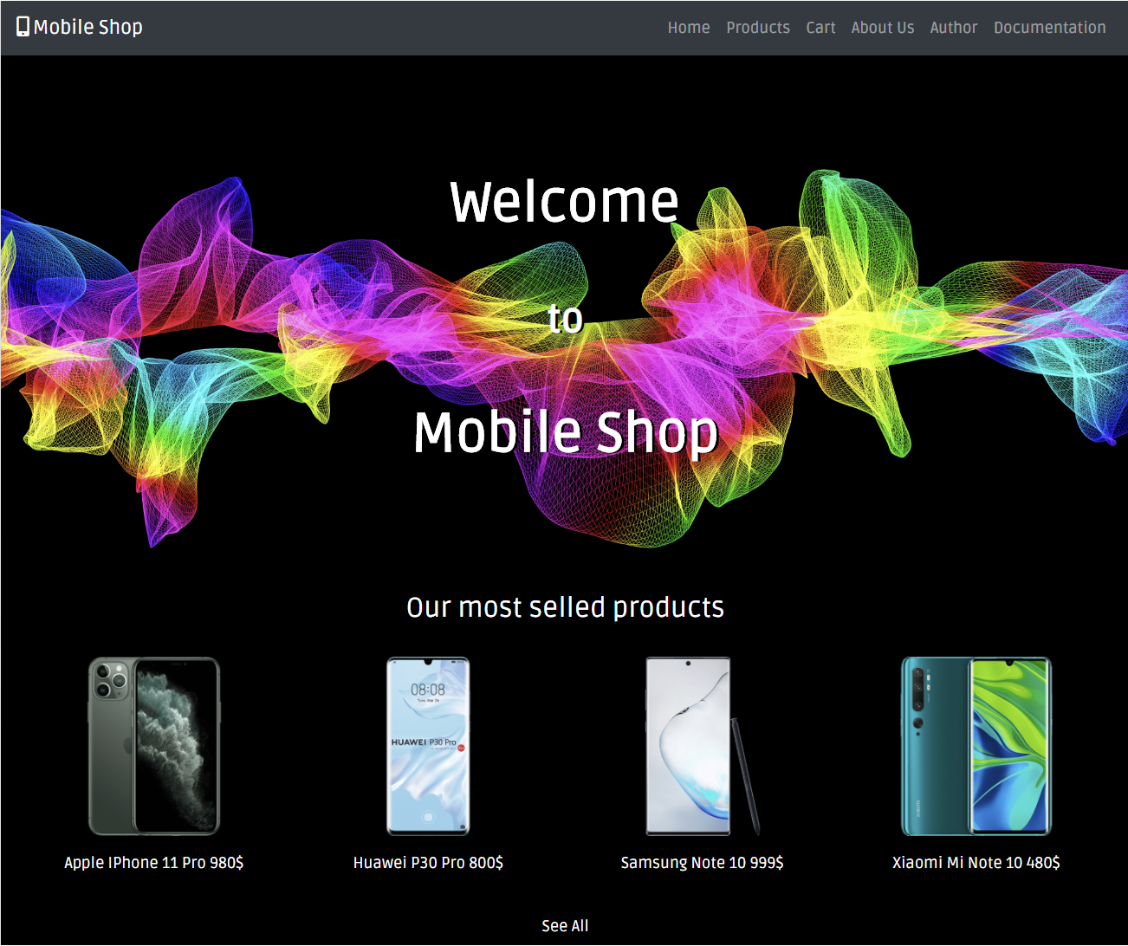

### Index.html – Članovi tima, Brendovi, Rapair Service I Forma

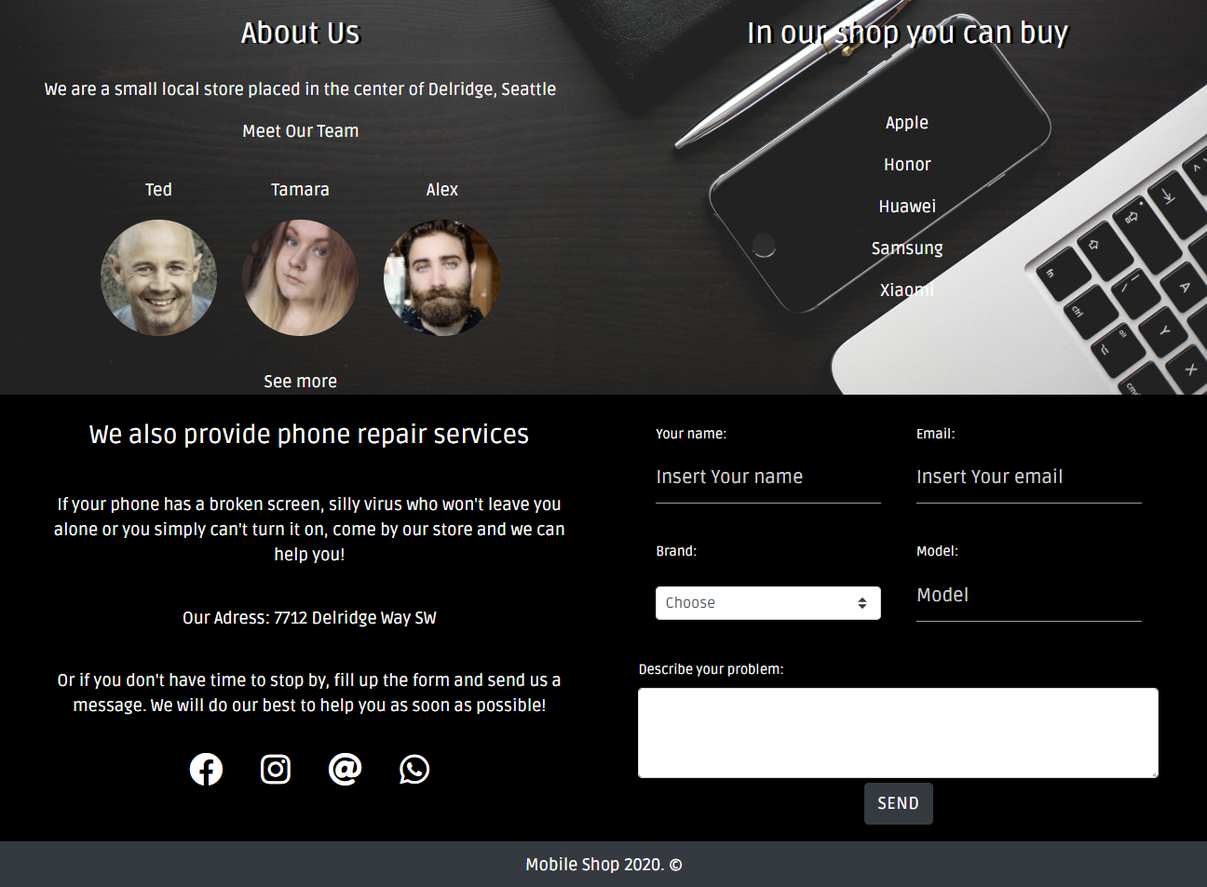

Klikom na dugme Send,podaci se pomoću regularnih izraza validiraju. Ukoliko uneta vrednost na odgovara kriterijumima, pojavljuje se crvena linija oko polja koje nije u redu.

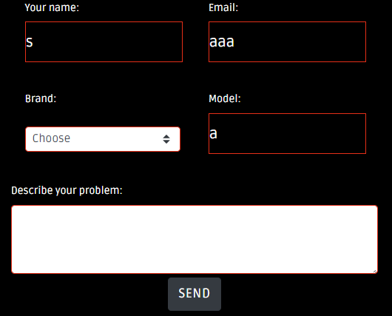

### Products.html – Prikaz proizvoda

Na ovoj stranici se inicijalno prikazuju svi proizvodi. Klikom na neki brend, izborom operativnog sistema ili memorije telefona, proizvodi se filtriraju. Izborom sort opcije, sortiraju se po zadatom kriterijumu.

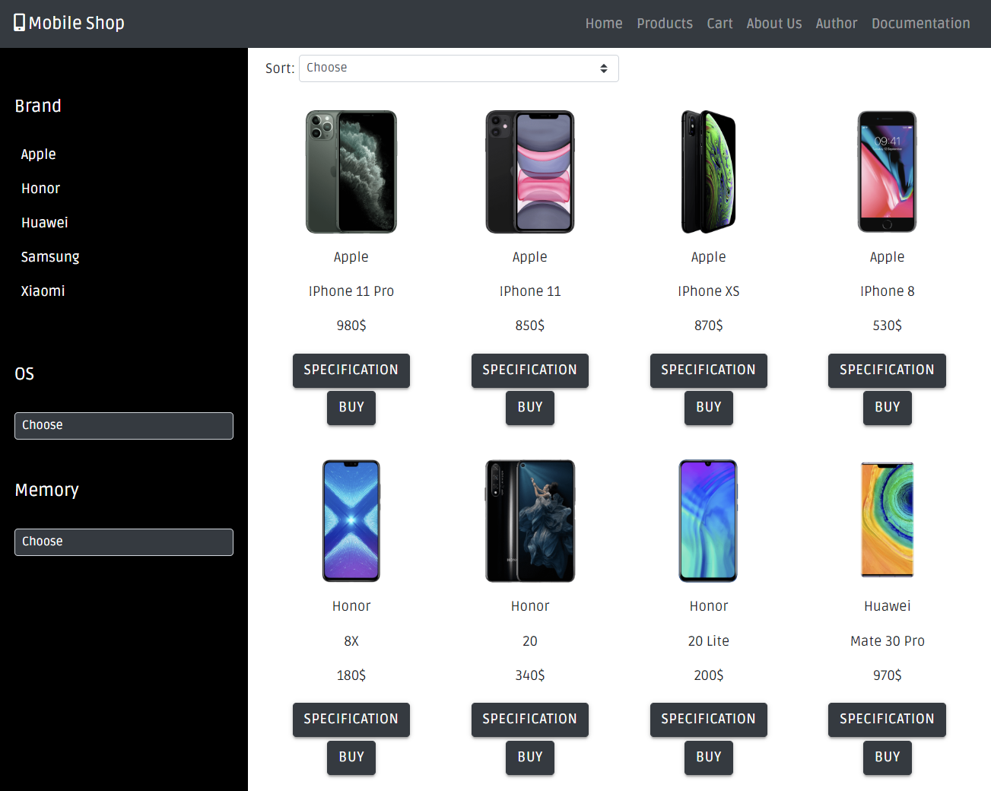

Klikom na dugme Specification prikazuju se dodatni podaci o proizvodu.

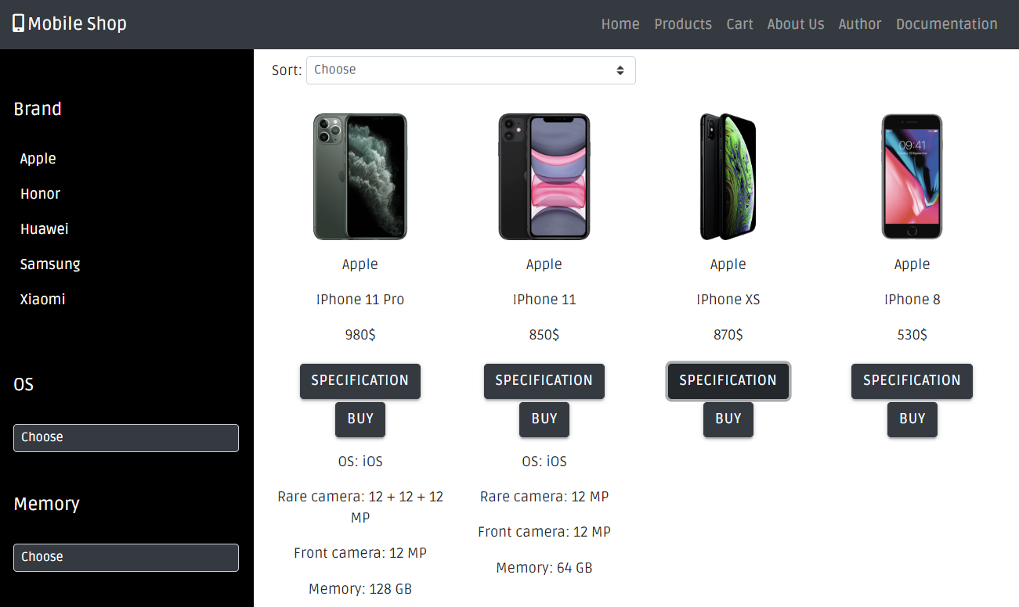

Klikom na dugme Buy, proizvod se ubacuje u korpu.

### Cart.html – Prikaz korpe

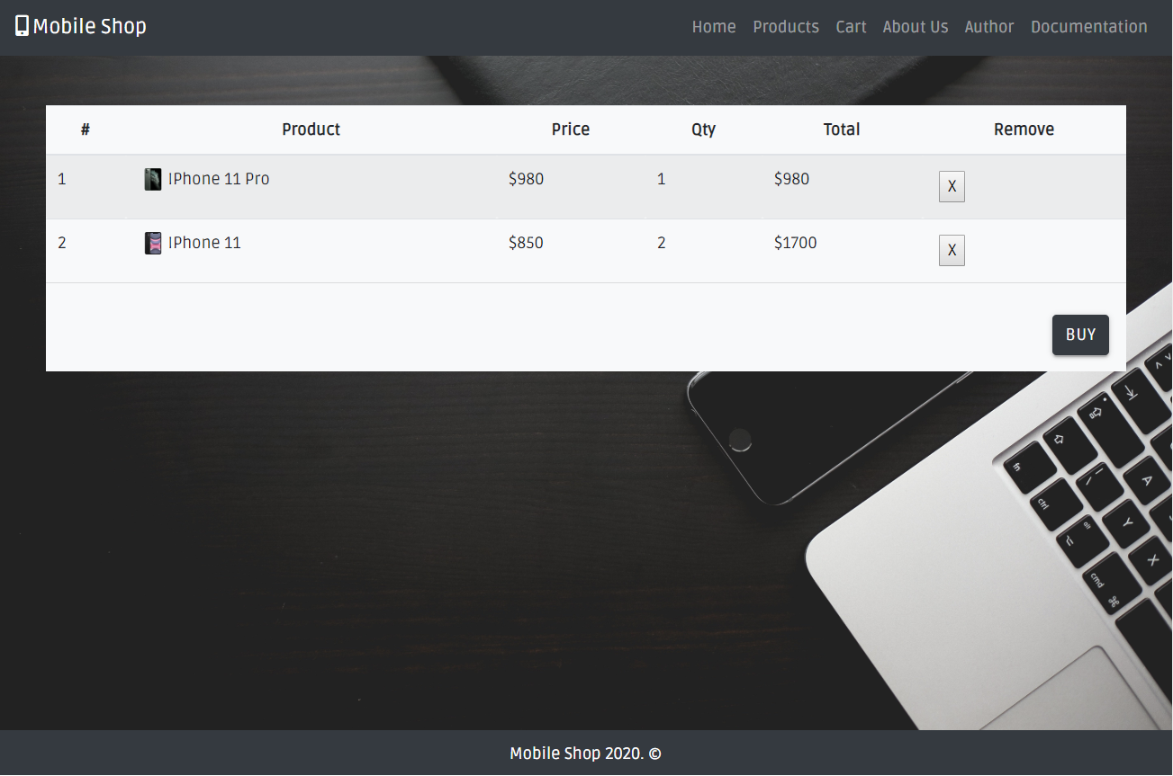

Ako u korpi nema proizvoda prikazuje se sledeći tekst.

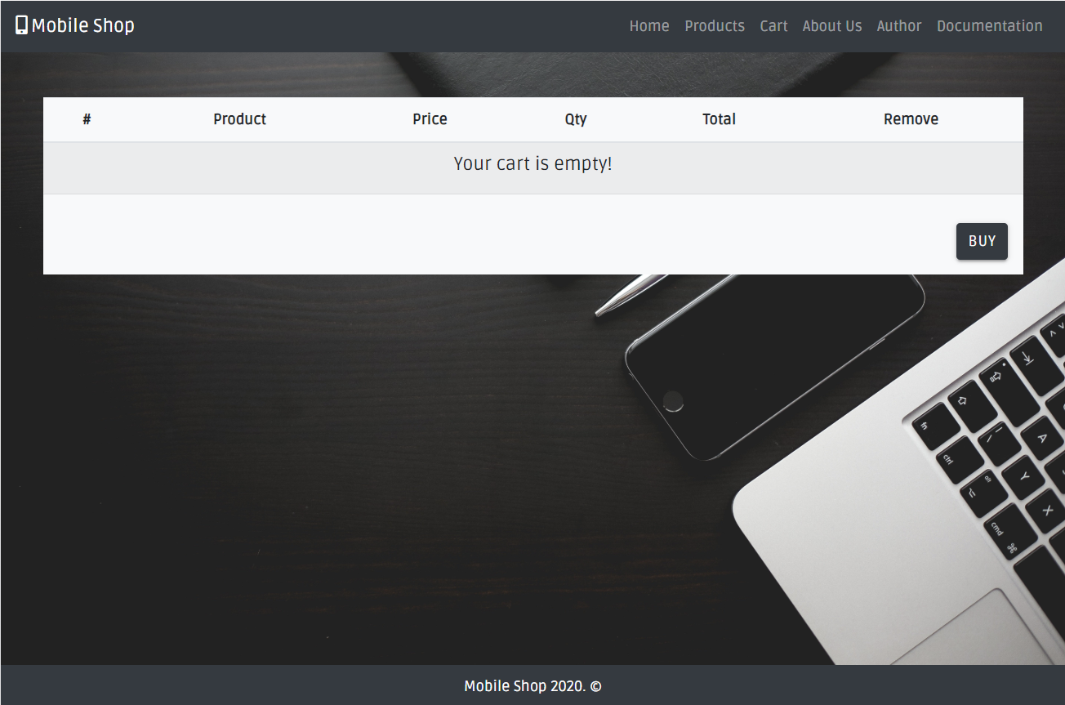

### Aboutus.html – Informacije o članovima tima I komentari kupaca

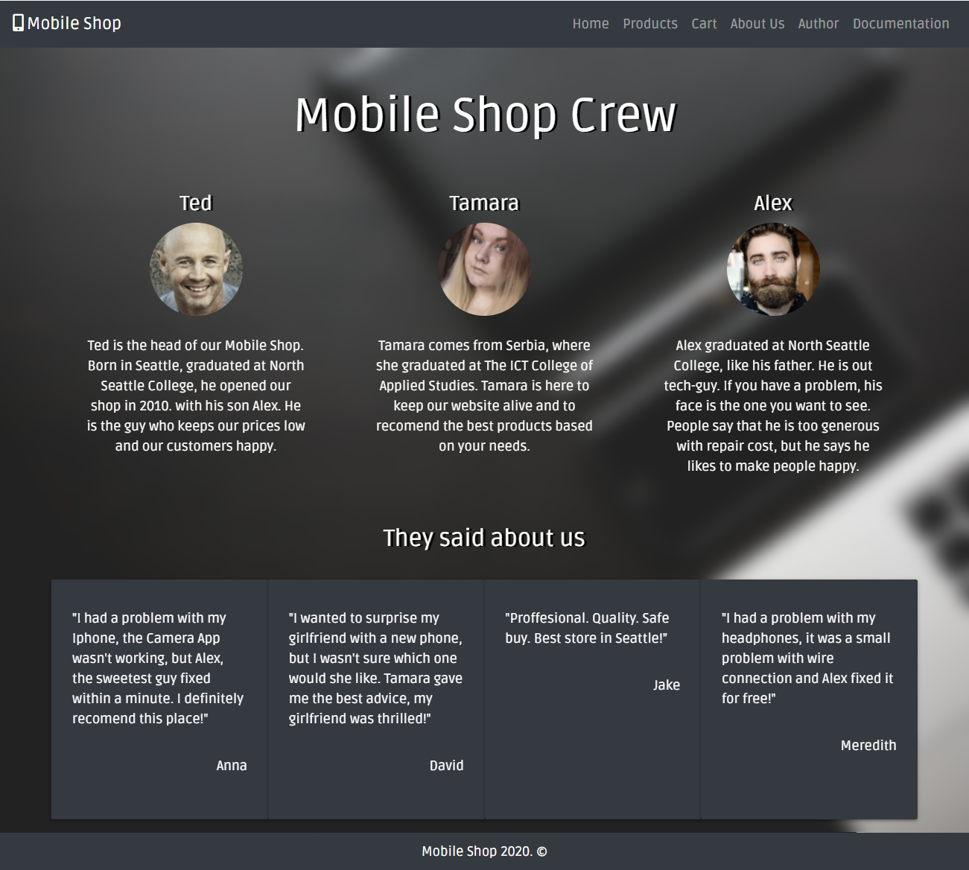

### Autor.html – Podaci o autoru

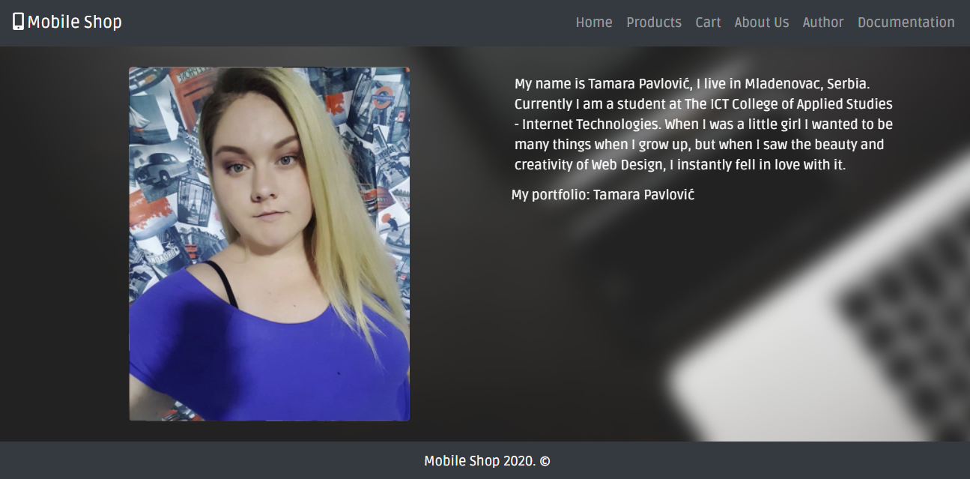

# Kodovi

## Index.html

<!DOCTYPE html>

<html lang="en">

<head>

    <meta charset="UTF-8">

    <meta name="viewport" content="width=device-width, initial-scale=1.0">

    <meta http-equiv="X-UA-Compatible" content="ie=edge">

    <title>Mobile Shop</title>

    <meta name="description" content="Welcome to Mobile Shop! Here you can find latest mobile devices and equipment!">

    <meta name="keywords" content="mobile, shop, phone, services">

    <meta name="robots" content="index, follow" />

    <link rel="shortcut icon" href="images/favicon.ico" type="image/x-icon">

    <link href="https://fonts.googleapis.com/css?family=Calligraffitti|Ruda&display=swap" rel="stylesheet">

    <script src="https://kit.fontawesome.com/6a571d5020.js"></script>

    <link href="https://fonts.googleapis.com/icon?family=Material+Icons" rel="stylesheet">

    <link rel="stylesheet" href="https://cdnjs.cloudflare.com/ajax/libs/materialize/1.0.0/css/materialize.min.css">

    <link rel="stylesheet" href="https://stackpath.bootstrapcdn.com/bootstrap/4.3.1/css/bootstrap.min.css" integrity="sha384-ggOyR0iXCbMQv3Xipma34MD+dH/1fQ784/j6cY/iJTQUOhcWr7x9JvoRxT2MZw1T" crossorigin="anonymous">

    <link rel="stylesheet" type="text/css" href="assets/css/style.css"/>

</head>

<body>

    <div class="container-fluid navbar navbar-expand-sm navbar-dark bg-dark white-text">

            <a class="navbar-brand" href="index.html"><i class="fas fa-mobile-alt mr-1"></i>Mobile Shop</a>

            <button class="navbar-toggler" type="button" data-toggle="collapse" data-target="#meni" aria-controls="meni" aria-expanded="false" aria-label="Toggle navigation"> <span class="navbar-toggler-icon"></span></button>

          <div class="collapse navbar-collapse" id="meni">

            </div>

    </div>

    <div id="welcome" class="p-5">

        <div id="welcometext">

            <h1 class="p-5">Welcome</h1>

            <h2 class="p-1">to</h2>

            <h1 class="p-5">Mobile Shop</h1>

         </div>

    </div>

    <div class="container-fluid" id="topProizvodi">

        <h3 class="text-center text-white pt-2">Our most selled products</h3>

        <div class="row pt-2 m-0" id="topProduct">

         </div>

        <p class="text-center p-2 m-0"><a class="text-white" href="products.html">See All</a></p>

    </div>

    <div class="container-fluid p-0" id="us" >

      <div class="row m-0">

        <div class="col-sm-12 col-md-6 col-lg-6">

          <h3 class="p-3 text-center">About Us</h3>

          <p class="text-center">We are a small local store placed in the center of Delridge, Seattle</p>

          <p class="text-center">Meet Our Team</p>

          <ul class="text-center p-2 mt-2 list-inline" id="crew1">

          </ul>

          <a class="text-white" href="aboutus.html">See more</a>

        </div>

        <div class="col-sm-12 col-md-6 col-lg-6">

          <h3 class="p-3 text-center">In our shop you can buy</h3>

          <ul class="text-center p-4 mt-2"id="buy">

          </ul>

        </div>

      </div>

     </div>

      <div class="container-fluid" id="services">

        <div class="row m-0">

            <div class="col-md-6 col-sm-12 pt-2">

                    <h4 class="text-center p-3">We also provide phone repair services</h4>

                    <p class="text-center p-3">If your phone has a broken screen, silly virus who won't leave you alone or you simply can't turn it on, come by our store and we can help you!</p>

                    <p class="text-center p-1">Our Adress: 7712 Delridge Way SW</p>

                    <p class="text-center p-3">Or if you don't have time to stop by, fill up the form and send us a message. We will do our best to help you as soon as possible!</p>

                    <p class="text-center"><a class="text-white p-3 icons" href="#"><i class="fab fa-facebook fa-2x"></i></a>

                      <a class="text-white p-3 icons" href="#"><i class="fab fa-instagram fa-2x"></i></a>

                      <a class="text-white p-3 icons" href="#"><i class="fas fa-at fa-2x"></i></a>

                      <a class="text-white p-3 icons" href="#"><i class="fab fa-whatsapp fa-2x" ></i></a></p>

            </div>

            <div class="col-md-6 col-sm-12 pt-2">

              <form class="m-3" name="autorcontact" action="" method="get" id="autorcontact">

                <div class="row p-0 m-0">

                  <div class="col-6">

                    <label class="white-text" for="name">Your name:</label>

                    <input id="name" class="white-text" type="text" placeholder="Insert Your name" name="name" required>

                  </div>

                  <div class="col-6">

                    <label class="white-text" for="email">Email:</label><br/>

                    <input id="email" class="white-text" type="email" placeholder="Insert Your email" name="email" required>

                  </div>

                </div>

                      <br/>

                 <div class="row p-0 m-0">

                  <div class="col-6">

                    <label class="white-text" for="email">Brand:</label>

                    <div id="formBrand">

                    </div>

                  </div>

                  <div class="col-6">

                    <label class="white-text" for="model">Model:</label>

                    <input id="model" class="white-text" type="text" placeholder="Model" name="model">

                  </div>

                </div><br/>

                      <label class="white-text" for="message">Describe your problem:</label><br/>

                      <textarea id="message" class="white form-control black-text" rows="3"></textarea>

                      <div class="center">

                          <button id="sendMessage" type="submit" class="btn btn-dark btn-md white-text mt-1">Send</button>

                      </div>

              </form>

            </div>

        </div>

      </div>

      <div class="container-fluid bg-dark" id="footer">

            <p class="text-center white-text">Mobile Shop 2020. &copy;</p>

      </div>

      <script src="https://ajax.googleapis.com/ajax/libs/jquery/3.4.1/jquery.min.js"></script>

      <script src="https://stackpath.bootstrapcdn.com/bootstrap/4.3.1/js/bootstrap.min.js" integrity="sha384-JjSmVgyd0p3pXB1rRibZUAYoIIy6OrQ6VrjIEaFf/nJGzIxFDsf4x0xIM+B07jRM" crossorigin="anonymous"></script>

      <script src="https://cdnjs.cloudflare.com/ajax/libs/materialize/1.0.0/js/materialize.min.js"></script>

      <script src="assets/js/ispis.js"></script>

      <script src="assets/js/main.js"></script>

</body>

</html>

## Products.html

<!DOCTYPE html>

<html lang="en">

    <head>

        <meta charset="UTF-8">

        <meta name="viewport" content="width=device-width, initial-scale=1.0">

        <meta http-equiv="X-UA-Compatible" content="ie=edge">

        <title>Mobile Shop</title>

        <meta name="description" content="List of products available at our store.">

        <meta name="keywords" content="phone, samsung, huawei, iphone, xiaomi, honor">

        <meta name="robots" content="index, follow" />

        <link rel="shortcut icon" href="images/favicon.ico" type="image/x-icon">

        <link href="https://fonts.googleapis.com/css?family=Ruda&display=swap" rel="stylesheet">

        <script src="https://kit.fontawesome.com/6a571d5020.js"></script>

        <link href="https://fonts.googleapis.com/icon?family=Material+Icons" rel="stylesheet">

        <link rel="stylesheet" href="https://cdnjs.cloudflare.com/ajax/libs/materialize/1.0.0/css/materialize.min.css">

        <link rel="stylesheet" href="https://stackpath.bootstrapcdn.com/bootstrap/4.3.1/css/bootstrap.min.css" integrity="sha384-ggOyR0iXCbMQv3Xipma34MD+dH/1fQ784/j6cY/iJTQUOhcWr7x9JvoRxT2MZw1T" crossorigin="anonymous">

        <link rel="stylesheet" type="text/css" href="assets/css/style.css"/>

    </head>

<body>

        <div class="container-fluid navbar navbar-expand-sm navbar-dark bg-dark white-text">

            <a class="navbar-brand" href="index.html"><i class="fas fa-mobile-alt mr-1"></i>Mobile Shop</a>

                <button class="navbar-toggler" type="button" data-toggle="collapse" data-target="#meni" aria-controls="meni" aria-expanded="false" aria-label="Toggle navigation"> <span class="navbar-toggler-icon"></span></button>

                <div class="collapse navbar-collapse" id="meni">

                </div>

        </div>

        <div class="container-fluid p-0">

           <div class="row m-0 p-0">

             <div class="col-md-3 col-sm-12 pt-2" id="categories">

                 <h5 class="pt-5"><a id="brand" class="text-white" href="#">Brand</a></h5>

                 <ul class="pt-3" id="brend">

                 </ul>

                  <h5 class="pt-5">OS</h5>

                    <div id="os" class="pt-4">

                    </div>

                  <h5 class="pt-5">Memory</h5>

                    <div id="memory" class="pt-4 pb-4">

                    </div>

             </div>

             <div class="col-md-9 col-sm-12 pt-2">

                 <div class="row m-0">

                     <div class="col-6 p-0 m-0 d-flex flex-row">

                        <p class="p-1">Sort:</p>

                        <select id="sort" name="sort" class="custom-select custom-select-sm">

                            <option value="0">Choose</option>

                            <option class="sortiraj" data-sort="name" data-order="asc" value="1">Name A-Z</option>

                            <option class="sortiraj" data-sort="name" data-order="desc" value="2">Name Z-A</option>

                            <option class="sortiraj" data-sort="price" data-order="asc" value="3">Price low to high</option>

                            <option class="sortiraj" data-sort="price" data-order="desc" value="4">Price high to low</option>

                        </select>

                     </div>

                 </div>

                <div class="row m-0" id="products">

                </div>

             </div>

           </div>

        </div>

        <div class="container-fluid bg-dark" id="footer">

            <p class="text-center white-text">Mobile Shop 2020. &copy;</p>

      </div>

      <script src="https://ajax.googleapis.com/ajax/libs/jquery/3.4.1/jquery.min.js"></script>

      <script src="https://stackpath.bootstrapcdn.com/bootstrap/4.3.1/js/bootstrap.min.js" integrity="sha384-JjSmVgyd0p3pXB1rRibZUAYoIIy6OrQ6VrjIEaFf/nJGzIxFDsf4x0xIM+B07jRM" crossorigin="anonymous"></script>

      <script src="https://cdnjs.cloudflare.com/ajax/libs/materialize/1.0.0/js/materialize.min.js"></script>

      <script src="assets/js/ispis.js"></script>

      <script src="assets/js/main.js"></script>

</body>

</html>

## Cart.html

<!DOCTYPE html>

<html lang="en">

    <head>

        <meta charset="UTF-8">

        <meta name="viewport" content="width=device-width, initial-scale=1.0">

        <meta http-equiv="X-UA-Compatible" content="ie=edge">

        <title>Mobile Shop</title>

        <meta name="description" content="Shopping cart">

        <meta name="keywords" content="cart, item, price">

        <meta name="robots" content="index, follow" />

        <link rel="shortcut icon" href="images/favicon.ico" type="image/x-icon">

        <link href="https://fonts.googleapis.com/css?family=Ruda&display=swap" rel="stylesheet">

        <script src="https://kit.fontawesome.com/6a571d5020.js"></script>

        <link href="https://fonts.googleapis.com/icon?family=Material+Icons" rel="stylesheet">

        <link rel="stylesheet" href="https://cdnjs.cloudflare.com/ajax/libs/materialize/1.0.0/css/materialize.min.css">

        <link rel="stylesheet" href="https://stackpath.bootstrapcdn.com/bootstrap/4.3.1/css/bootstrap.min.css" integrity="sha384-ggOyR0iXCbMQv3Xipma34MD+dH/1fQ784/j6cY/iJTQUOhcWr7x9JvoRxT2MZw1T" crossorigin="anonymous">

        <link rel="stylesheet" type="text/css" href="assets/css/style.css"/>

    </head>

<body>

        <div class="container-fluid navbar navbar-expand-sm navbar-dark bg-dark white-text">

            <a class="navbar-brand" href="index.html"><i class="fas fa-mobile-alt mr-1"></i>Mobile Shop</a>

                <button class="navbar-toggler" type="button" data-toggle="collapse" data-target="#meni" aria-controls="meni" aria-expanded="false" aria-label="Toggle navigation"> <span class="navbar-toggler-icon"></span></button>

                <div class="collapse navbar-collapse" id="meni">

                </div>

        </div>

        <div class="container-fluid pt-5 m-0 black" id="cart">

            <div class="container bg-light">

                <div class="row">

                    <table class="table table-striped">

                        <thead>

                          <tr>

                            <th scope="col">#</th>

                            <th scope="col">Product</th>

                            <th scope="col">Price</th>

                            <th scope="col">Qty</th>

                            <th scope="col">Total</th>

                            <th scope="col">Remove</th>

                          </tr>

                        </thead>

                        <tbody id="itemsInCart">

                        </tbody>

                      </table>

                      <div class="ml-auto">

                          <button id="kupi" class="btn bg-dark text-light m-3" value="Buy">Buy</button>

                      </div>

                </div>

            </div>

        </div>

        <div class="container-fluid bg-dark" id="footer">

            <p class="text-center white-text">Mobile Shop 2020. &copy;</p>

      </div>

      <script src="https://ajax.googleapis.com/ajax/libs/jquery/3.4.1/jquery.min.js"></script>

      <script src="https://stackpath.bootstrapcdn.com/bootstrap/4.3.1/js/bootstrap.min.js" integrity="sha384-JjSmVgyd0p3pXB1rRibZUAYoIIy6OrQ6VrjIEaFf/nJGzIxFDsf4x0xIM+B07jRM" crossorigin="anonymous"></script>

      <script src="https://cdnjs.cloudflare.com/ajax/libs/materialize/1.0.0/js/materialize.min.js"></script>

      <script src="assets/js/ispis.js"></script>

      <script src="assets/js/main.js"></script>

      <script src="assets/js/cart.js"></script>

</body>

</html>

## Aboutus.html

<!DOCTYPE html>

<html lang="en">

    <head>

        <meta charset="UTF-8">

        <meta name="viewport" content="width=device-width, initial-scale=1.0">

        <meta http-equiv="X-UA-Compatible" content="ie=edge">

        <title>Mobile Shop</title>

        <meta name="description" content="Meet our shop crew who will help you with any problem.">

        <meta name="keywords" content="crew, shop, about ">

        <meta name="robots" content="index, follow" />

        <link rel="shortcut icon" href="images/favicon.ico" type="image/x-icon">

        <link href="https://fonts.googleapis.com/css?family=Ruda&display=swap" rel="stylesheet">

        <script src="https://kit.fontawesome.com/6a571d5020.js"></script>

        <link href="https://fonts.googleapis.com/icon?family=Material+Icons" rel="stylesheet">

        <link rel="stylesheet" href="https://cdnjs.cloudflare.com/ajax/libs/materialize/1.0.0/css/materialize.min.css">

        <link rel="stylesheet" href="https://stackpath.bootstrapcdn.com/bootstrap/4.3.1/css/bootstrap.min.css" integrity="sha384-ggOyR0iXCbMQv3Xipma34MD+dH/1fQ784/j6cY/iJTQUOhcWr7x9JvoRxT2MZw1T" crossorigin="anonymous">

        <link rel="stylesheet" type="text/css" href="assets/css/style.css"/>

    </head>

<body>

        <div class="container-fluid navbar navbar-expand-sm navbar-dark bg-dark white-text">

                <a class="navbar-brand" href="index.html"><i class="fas fa-mobile-alt mr-1"></i>Mobile Shop</a>

                <button class="navbar-toggler" type="button" data-toggle="collapse" data-target="#meni" aria-controls="meni" aria-expanded="false" aria-label="Toggle navigation"> <span class="navbar-toggler-icon"></span></button>

              <div class="collapse navbar-collapse" id="meni">

                </div>

        </div>

<div class="container-fluid text-center p-0" id="aboutus">

<div class="blur">

    <div class="container">

        <h1 class="p-5">Mobile Shop Crew</h1>

        <div class="row m-0" id="crew2">

        </div>

        <div>

                <h3 class="p-3 text-center">They said about us</h3>

        </div>

        <div class="row m-0" id="comments">

        </div>

    </div>

</div>

</div>

<div class="container-fluid bg-dark" id="footer">

        <p class="text-center white-text">Mobile Shop 2020. &copy;</p>

  </div>

    <script src="https://ajax.googleapis.com/ajax/libs/jquery/3.4.1/jquery.min.js"></script>

    <script src="https://cdnjs.cloudflare.com/ajax/libs/popper.js/1.14.7/umd/popper.min.js" integrity="sha384-UO2eT0CpHqdSJQ6hJty5KVphtPhzWj9WO1clHTMGa3JDZwrnQq4sF86dIHNDz0W1" crossorigin="anonymous"></script>

    <script src="https://stackpath.bootstrapcdn.com/bootstrap/4.3.1/js/bootstrap.min.js" integrity="sha384-JjSmVgyd0p3pXB1rRibZUAYoIIy6OrQ6VrjIEaFf/nJGzIxFDsf4x0xIM+B07jRM" crossorigin="anonymous"></script>

    <script src="https://cdnjs.cloudflare.com/ajax/libs/materialize/1.0.0/js/materialize.min.js"></script>

    <script src="assets/js/ispis.js"></script>

    <script src="assets/js/main.js"></script>

</body>

</html>

## Autor.html

<!DOCTYPE html>

<html lang="en">

<head>

    <meta charset="UTF-8">

    <meta name="viewport" content="width=device-width, initial-scale=1.0">

    <meta http-equiv="X-UA-Compatible" content="ie=edge">

    <title>Mobile Shop</title>

    <meta name="description" content="Find out something about author of this site.">

    <meta name="keywords" content="about me, autor">

    <meta name="robots" content="index, follow" />

    <link rel="shortcut icon" href="images/favicon.ico" type="image/x-icon">

    <link href="https://fonts.googleapis.com/css?family=Ruda&display=swap" rel="stylesheet">

    <script src="https://kit.fontawesome.com/6a571d5020.js"></script>

    <link href="https://fonts.googleapis.com/icon?family=Material+Icons" rel="stylesheet">

    <link rel="stylesheet" href="https://cdnjs.cloudflare.com/ajax/libs/materialize/1.0.0/css/materialize.min.css">

    <link rel="stylesheet" href="https://stackpath.bootstrapcdn.com/bootstrap/4.3.1/css/bootstrap.min.css" integrity="sha384-ggOyR0iXCbMQv3Xipma34MD+dH/1fQ784/j6cY/iJTQUOhcWr7x9JvoRxT2MZw1T" crossorigin="anonymous">

    <link rel="stylesheet" type="text/css" href="assets/css/style.css"/>

</head>

<body>

    <div class="container-fluid navbar navbar-expand-sm navbar-dark bg-dark white-text">

        <a class="navbar-brand" href="index.html"><i class="fas fa-mobile-alt mr-1"></i>Mobile Shop</a>

        <button class="navbar-toggler" type="button" data-toggle="collapse" data-target="#meni" aria-controls="meni" aria-expanded="false" aria-label="Toggle navigation"> <span class="navbar-toggler-icon"></span></button>

        <div class="collapse navbar-collapse" id="meni">

        </div>

        </div>

        <div class="container-fluid p-0 m-0" id="autor">

            <div class="blur">

                <div class="container">

                    <div class="row p-0 m-0">

                        <div class="col-sm-12 col-md-6 col-lg-6" id="autorimg" ><img class="rounded-lg m-4 img-fluid"  src="images/autor.png" alt="autor"/></div>

                        <div class="col-sm-12 col-md-6 col-lg-6 p-4"><p class="text-left p-1 m-1">My name is Tamara Pavlović, I live in Mladenovac, Serbia. Currently I am a student at The ICT College of Applied Studies - Internet Technologies. When I was a little girl I wanted to be many things when I grow up, but when I saw the beauty and creativity of Web Design, I instantly fell in love with it.</p>

                        <p class="text-left p-1 m-0">My portfolio: <a class="text-white" href="https://tampavportfolio.000webhostapp.com/">Tamara Pavlović</a></p>

                    </div>

                </div>

                </div>

            </div>

        </div>

            <div class="container-fluid bg-dark" id="footer">

                <p class="text-center white-text">Mobile Shop 2020. &copy;</p>

          </div>

      <script src="https://ajax.googleapis.com/ajax/libs/jquery/3.4.1/jquery.min.js"></script>

      <script src="https://stackpath.bootstrapcdn.com/bootstrap/4.3.1/js/bootstrap.min.js" integrity="sha384-JjSmVgyd0p3pXB1rRibZUAYoIIy6OrQ6VrjIEaFf/nJGzIxFDsf4x0xIM+B07jRM" crossorigin="anonymous"></script>

      <script src="https://cdnjs.cloudflare.com/ajax/libs/materialize/1.0.0/js/materialize.min.js"></script>

      <script src="assets/js/ispis.js"></script>

      <script src="assets/js/main.js"></script>

</body>

</html>

## style.css

body {

    font-family: 'Ruda', sans-serif;

}

h1 {

    font-size: 3.5rem;

}

h2 {

    font-size: 2.5rem;

}

h1, h2, h3, h4 {

    text-shadow: 3px 1px 0px black;

}

#welcome {

    background-image: url("../../images/background.jpg");

    background-size: cover;

    background-repeat: no-repeat;

    background-position:right top;

    text-align: center;

    color:white;

}

#welcometext {

    margin: 20px auto;

    -webkit-text-stroke: 1px #FFF;

}

#topProizvodi {

    background-color: black;

}

#us {

    background-image: url("../../images/office.jpg");

    background-size: cover;

    background-repeat: no-repeat;

    background-position: center;

    text-align: center;

    color:white;

}

#services {

    background-color:black;

    color:white;

}

#aboutus, #autor, #cart {

    background-image: url("../../images/office.jpg");

    background-size: cover;

    background-repeat: no-repeat;

    background-position: center;

    text-align: center;

    color:white;

}

#autorimg {

    margin: 0 auto;

}

.blur {

    backdrop-filter: blur(10px);

}

#footer  {

    padding-top:10px;

    padding-bottom:10px;

    padding-left:0;

    padding-right:0;

    height:40px;

}

#footer p {

    margin-bottom:0;

}

input:focus {

    border-bottom: 1px solid white !important;

}

.error {

    border: 1px solid red !important;

}

.grow {

transition: all .2s ease-in-out;

}

.grow:hover {

transform: scale(1.1);

}

.icons:hover {

    border-bottom: 1px solid white;

}

#categories {

    background-color: black;

    color: white;

}

#cart {

    min-height:600px;

}

@media only screen and (max-width: 450px) {

    h1 {

        font-size:32px;

    }

    h2 {

        font-size:25px;

    }

}

@media only screen and (min-width: 815px) {

    #welcometext {

        width:50%;

    }

}

@media only screen and (min-width: 768px) {

    .full {

        height: 100vh;

    }

}

## Ispis.js

$(document).ready(function(){

    $("#sort").change(sortiraj);

    showProducts();

    $("#brand").click(showProducts);

    //Meni

    $.ajax({

        url : "assets/data/menu.json",

        method : "GET",

        dataType : "json",

        success: function(meni){

            ispis= `<ul class="navbar-nav ml-auto">`;

            for(let m of meni){

                ispis += `<li class="nav-item ">

                            <a class="nav-link" href="${m.href}">${m.name}</a>

                        </li>`;

            }

            ispis += `</ul>`;

            $("#meni").html(ispis);

        },

        error : function(xhr, error, status) {

            alert(status);

        }

    })

    //Kategorije

    $.ajax({

        url : "assets/data/categories.json",

        method : "GET",

        dataType : "json",

        success: function(categories){

            iBrend = ``;

            iOs= `<select id="os" name="os" class="custom-select custom-select-sm bg-dark text-white"><option value="0">Choose</option>`;

            iMemory= `<select id="os" name="os" class="custom-select custom-select-sm bg-dark text-white"><option value="0">Choose</option>`;

            bBrend = ``;

            fBrend= `<select id="fBrend" name="fBrend" class="custom-select custom-select-sm mt-3"><option value="0">Choose</option>`;

            for(let cat of categories){

                if (cat.type == 'brand'){

                    iBrend += `<li class="p-2"><a data-id="${cat.id}" class="text-white filter" href="products.html">${cat.category}</a></li>`;

                    bBrend += `<li class="p-2 text-white">${cat.category}</li>`;

                    fBrend += `<option value="${cat.id}">${cat.category}</option>`;

                }

                else if (cat.type == 'os'){

                iOs += `<option value="${cat.id}">${cat.category}</option>`;

                }

                else if (cat.type == 'memory'){

                iMemory += `<option value="${cat.id}">${cat.category}</option>`;

                }

            }

            iOs+=`</select>`;

            iMemory+=`</select>`;

            fBrend += `</select>`;

            $("#brend").html(iBrend);

            $("#buy").html(bBrend);

            $("#os").html(iOs);

            $("#memory").html(iMemory);

            $("#formBrand").html(fBrend);

            $(".filter").click(filtrirajBrend);

            $("#os").change(filtrirajOs);

            $("#memory").change(filtrirajMemory);

        },

        error : function(xhr, error, status) {

            alert(status);

        }

    })

    //Zaposleni

    $.ajax({

        url : "assets/data/crew.json",

        method : "GET",

        dataType : "json",

        success: function(crew){

            ispisIndex= ``;

            ispisAbout= ``;

            for(let c of crew){

                ispisIndex += `<li class="list-inline-item p-2"><p class="text-center">${c.name}</p><img class="rounded-circle" src="${c.image}"/></li>`;

                ispisAbout += `<div class="col-sm-12 col-md-6 col-lg-4">

                            <h4 class="text-center">${c.name}</h4>

                            <img class="rounded-circle" src="${c.image}"/>

                            <p class="p-4">${c.description}</p>

                        </div>`;

            }

            $("#crew1").html(ispisIndex);

            $("#crew2").html(ispisAbout);

        },

        error : function(xhr, error, status) {

            alert(status);

        }

    })

    //Komentari

    $.ajax({

        url : "assets/data/comments.json",

        method : "GET",

        dataType : "json",

        success: function(comments){

            ispis= ``;

            for(let com of comments){

                ispis += `<div class="col-sm-12 col-md-6 col-lg-3 card-panel bg-dark">

                <p class="text-left p-2">"${com.comment}"</p>

                <p class="text-right p-2">${com.name}</p>

        </div>`;

            }

            $("#comments").html(ispis);

        },

        error : function(xhr, error, status) {

            alert(status);

        }

    })

    //Top proizvodi

    ajaxProducts(function(products){

            ispis= ``;

            for(let p of products){

                if(p.top)

                ispis += `<div class="col-sm-12 col-md-6 col-lg-3">

                             <div class="text-center card black grow">

                                 <a href="products.html"><img src="${p.image.src}" alt="${p.image.alt}" class="card-img-top mb-3 mt-2"/></a>

                                <p class="text-white">${p.brand.name} ${p.name} ${p.price}$</p>

                            </div>

                         </div>`;

            }

            $("#topProduct").html(ispis);

        }

        );

});

function ajaxProducts(callbackSuccess){

    $.ajax({

        url: "assets/data/products.json",

        method: "GET",

        success: callbackSuccess

    });

}

function showProducts() {

    ajaxProducts(function(products){

            ispis= ``;

                printProduct(products);

        }

    );

}

function filtrirajBrend(blok){

    blok.preventDefault();

    let catId = $(this).data('id');

    ajaxProducts(function(products){

            products = products.filter(x => x.brand.id == catId);

            ispis= ``;

            printProduct(products);

         }

    );

}

function printProduct(products) {

    for(let p of products){

    ispis += `<div class="col-lg-3 col-md-6 col-sm-12 p-2">

    <img class="card-img-top mb-3 mt-2" src="${p.image.src}" alt="${p.image.alt}"/>

    <p class="text-center">${p.brand.name}</p>

    <p class="text-center">${p.name}</p>

    <p class="text-center">${p.price}$</p>

    <p class="text-center">

        <a class="btn btn-dark mt-1" data-toggle="collapse" href="#collapse${p.id}" role="button" aria-expanded="false" aria-controls="collapse${p.id}">Specification</a>

        <a class="btn btn-dark storage mt-1" data-id="${p.id}" role="button" href="#">Buy</a>

    </p>

    <div class="collapse" id="collapse${p.id}">

            <p class="text-center p-0">OS: ${p.os}</p>

            <p class="text-center p-0">Rare camera: ${p.camera.rare} MP</p>

            <p class="text-center p-0">Front camera: ${p.camera.front} MP</p>

            <p class="text-center p-0">Memory: ${p.memory} GB</p>

    </div>

    </div>`;

}

$("#products").html(ispis);

$(".storage").click(addToCart);

}

function filtrirajOs(){

    var os = $("#os option:selected").text();

    ajaxProducts(function(products){

            ispis= ``;

            if(os == "Choose") {

                    printProduct(products);

            }

            else {

            products = products.filter(x => x.os == os);

                printProduct(products);

            }

        }

    );

}

function filtrirajMemory(){

    var memory = $("#memory option:selected").text();

    ajaxProducts(function(products){

            ispis= ``;

            if(memory == "Choose") {

                    printProduct(products);

            }

            else {

            products = products.filter(x => x.memory == memory);

                printProduct(products);

            }

        }

    );

}

function sortiraj(){

    let sort = $(this).find(':selected').data('sort');

    let order = $(this).find(':selected').data('order');

    var os = $("#os option:selected").text();

    var memory = $("#memory option:selected").text();

    ajaxProducts(function(products){

            if(os == "Choose" || memory == "Choose")

            {

                ispis = ``;

                sortiranje(products, sort, order);

                printProduct(products);

            }

            if(os == "Choose" && memory !== "Choose")

            {

                ispis = ``;

                var x = products.filter(x => x.memory == memory);

                sortiranje(x, sort, order);

                printProduct(x);

            }

            if(os !== "Choose" && memory == "Choose")

            {

                ispis = ``;

                var x = products.filter(x => x.os == os);

                sortiranje(products, sort, order);

                printProduct(x);

            }

            if(os !== "Choose" && memory !== "Choose")

            {

                ispis = ``;

                products = products.filter(x => x.os == os);

                products = products.filter(x => x.memory == memory);

                sortiranje(products, sort, order);

                printProduct(products);

            }

        }

    );

}

function sortiranje(products, sort, order) {

    products.sort(function(x,y){

        let first = (sort=="price")? x.price : x.name;

        let second = (sort=="price")? y.price : y.name;

        if(first > second)

            return order=='asc' ? 1 : -1;

        else if(first < second)

            return order=='asc' ? -1 : 1;

        else

            return 0;

    });

}

function productsInCart() {

    return JSON.parse(localStorage.getItem("products"));

}

function addToCart(){

    let id = $(this).data("id");

    var products = productsInCart();

    if(products) {

        if(isItInCart()){

            addOneMore();

        }else {

            addToLocalStorage();

        }

    } else {

        addItemToLocalStorage();

    }

function isItInCart(){

    x = products.filter(x=> x.id == id).length;

    return x;

}

function addToLocalStorage(){

    let products = productsInCart();

    products.push({

        id:id,

        q:1

    });

    localStorage.setItem("products", JSON.stringify(products));

    alert("Item is added to cart!");

}

function addOneMore() {

    let products = productsInCart();

    for (let i in products) {

        if(products[i].id ==id){

            products[i].q++;

            break;

        }

    }

    localStorage.setItem("products", JSON.stringify(products));

    alert("Item is added to cart!");

}

function addItemToLocalStorage(){

    let products = [];

    products[0] = {

        id:id,

        q:1

    };

    localStorage.setItem("products", JSON.stringify(products));

    alert("Item is added to cart!");

}

}

## Main.js

window.onload = function (){

    $("#sendMessage").click(function(event){

        event.preventDefault();

        checkForm();

    });

}

function checkForm() {

    var poljeName = document.querySelector("#name");

    var poljeEmail = document.querySelector("#email");

    var poljeModel = document.querySelector("#model");

    var dropBrand = document.querySelector("#fBrend");

    var poljeMessage = document.querySelector("#message");

    var reName, reEmail, reModel;

    reName = /^[A-Z][a-z]{1,12}(\s[A-Z][a-z]{1,19})+$/;

    reModel = /^[A-Za-z0-9]{2,16}$/;

    reEmail = /^\w+([.-]?[\w\d]+)*@\w+([.-]?[\w]+)*(\.\w{2,4})+$/;

    if(poljeName.value == ""){

        poljeName.classList.add("error");

    }

    else{

        if(!reName.test(poljeName.value)){

            poljeName.classList.add("error");

        }else{

            poljeName.classList.remove("error");

        }

    }

    if(poljeEmail.value == ""){

        poljeEmail.classList.add("error");

    }

    else{

        if(!reEmail.test(poljeEmail.value)){

            poljeEmail.classList.add("error");

        }else{

            poljeEmail.classList.remove("error");

        }

    }

    if(poljeModel.value == ""){

        poljeModel.classList.add("error");

    }

    else{

        if(!reModel.test(poljeModel.value)){

            poljeModel.classList.add("error");

        }else{

            poljeModel.classList.remove("error");

        }

    }

    if(dropBrand.value == 0){

        dropBrand.classList.add("error");

    }

    else{

        dropBrand.classList.remove("error");

    }

    if(poljeMessage.value == ""){

        poljeMessage.classList.add("error");

    }

    else{

        poljeMessage.classList.remove("error");

        }

}

## Cart.js

$(document).ready(function () {

    checkForProducts();

});

function displayCartData() {

    let products = JSON.parse(localStorage.getItem("products"));

    $.ajax({

        url : "assets/data/products.json",

        success : function(data) {

            let showProducts = [];

            data = data.filter(p => {

                for(let prod of products)

                {

                    if(p.id == prod.id) {

                        p.q = prod.q;

                        return true;

                    }

                }

                return false;

            });

            itemCreation(data)

        }

    });

}

function itemCreation(products) {

    let html = ``;

    let br=1;

    for(let p of products) {

        html += "<tr><td>"+br+"</td>";

        html += `<td><img src="${p.image.src}" style='height:20px' alt="${p.image.alt}" class="img-responsive center">${p.name}</td>

        <td>$${p.price}</td>

        <td>${p.q}</td>

        <td>$${p.price * p.q}</td>

        <td>

            <div>

                <div class="p-1"><button onclick='removeFromCart(${p.id})'>X</button> </div>

            </div>

        </td>

    </tr>`;

    br++;

    }

    $("#itemsInCart").html(html);

}

function showEmptyCart() {

    $("#itemsInCart").html("<tr><td class='center' colspan='6'><h5>Your cart is empty!</h5></td></tr>")

}

function removeFromCart(id) {

    let products = JSON.parse(localStorage.getItem("products"));

    let filtered = products.filter(p => p.id != id);

    localStorage.setItem("products", JSON.stringify(filtered));

    checkForProducts();

}

function checkForProducts() {

    let products = JSON.parse(localStorage.getItem("products"));

    console.log(products);

    if(products == null || products == 0)

        showEmptyCart();

    else

        displayCartData();

}

## Categories.json

[

    {

        "id" : 1,

        "category" : "Apple",

        "type" : "brand"

    },

    {

        "id" : 2,

        "category" : "Honor",

        "type" : "brand"

    },

    {

        "id" : 3,

        "category" : "Huawei",

        "type" : "brand"

    },

    {

        "id" : 4,

        "category" : "Samsung" ,

        "type" : "brand"

    },

    {

        "id" : 5,

        "category" : "Xiaomi"  ,

        "type" : "brand"

    },

    {

        "id" : 6,

        "category" : "iOS"  ,

        "type" : "os"

    },

    {

        "id" : 7,

        "category" : "Android"  ,

        "type" : "os"

    },

    {

        "id" : 8,

        "category" : "256"  ,

        "type" : "memory"

    },

    {

        "id" : 9,

        "category" : "128"  ,

        "type" : "memory"

    },

    {

        "id" : 10,

        "category" : "64"  ,

        "type" : "memory"

    },

    {

        "id" : 11,

        "category" : "32"  ,

        "type" : "memory"

    }

]

## Menu.json

[

    {

        "href" : "index.html",

        "name" : "Home"

    },

    {

        "href" : "products.html",

        "name" : "Products"

    },

    {

        "href" : "cart.html",

        "name" : "Cart"

    },

    {

        "href" : "aboutus.html",

        "name" : "About Us"

    },

    {

        "href" : "autor.html",

        "name" : "Author"

    },

    {

        "href" : "dokumantacija.pdf",

        "name" : "Documentation"

    }

]

## Products.json

[

        {

        "id" : 1,

        "image" : {

         "src" : "images/apple/apple-iphone-11-pro.png",

          "alt" : "iphone-11-pro"

        },

        "brand" : {

          "id" : 1,

          "name" :"Apple"

        },

        "name" : "IPhone 11 Pro",

        "price" : "980",

        "os" : "iOS",

        "camera" : {

          "rare" : "12 + 12 + 12",

          "front" : "12"

        },

        "memory":"128",

        "top" : true

    },

    {

        "id" : 2,

        "image" : {

         "src" : "images/apple/apple-iphone-11.png",

          "alt" : "iphone-11"

        },

        "brand" : {

          "id" : 1,

          "name" :"Apple"

        },

        "name" : "IPhone 11",

        "price" : "850",

        "os" : "iOS",

        "camera" : {

          "rare" : "12",

          "front" : "12"

        },

        "memory":"64",

        "top" : false

    },

    {

        "id" : 3,

        "image" : {

         "src" : "images/apple/apple-iphone-xs.png",

          "alt" : "iphone-xs"

        },

        "brand" : {

          "id" : 1,

          "name" :"Apple"

        },

        "name" : "IPhone XS",

        "price" : "870",

        "os" : "iOS",

        "camera" : {

          "rare" : "12 + 12",

          "front" : "7"

        },

        "memory":"256",

        "top" : false

    },

    {

        "id" : 4,

        "image" : {

         "src" : "images/apple/apple-iphone-8.png",

          "alt" : "iphone-8"

        },

        "brand" : {

          "id" : 1,

          "name" :"Apple"

        },

        "name" : "IPhone 8",

        "price" : "530",

        "os" : "iOS",

        "camera" : {

          "rare" : "12",

          "front" : "7"

        },

        "memory":"64",

        "top" : false

    },

    {

        "id" : 5,

        "image" : {

         "src" : "images/honor/honor-8x.png",

          "alt" : "honor-8x"

        },

        "brand" : {

          "id" : 2,

          "name" :"Honor"

        },

        "name" : "8X",

        "price" : "180",

        "os" : "Android",

        "camera" : {

          "rare" : "20",

          "front" : "16"

        },

        "memory":"64",

        "top" : false

    },

    {

        "id" : 6,

        "image" : {

         "src" : "images/honor/honor-20.png",

          "alt" : "honor-20"

        },

        "brand" : {

          "id" : 2,

          "name" :"Honor"

        },

        "name" : "20",

        "price" : "340",

        "os" : "Android",

        "camera" : {

          "rare" : "48 + 16 + 2",

          "front" : "32"

        },

        "memory":"128",

        "top" : false

    },

    {

        "id" : 7,

        "image" : {

         "src" : "images/honor/honor-20-lite.png",

          "alt" : "honor-20-lite"

        },

        "brand" : {

          "id" : 2,

          "name" :"Honor"

        },

        "name" : "20 Lite",

        "price" : "200",

        "os" : "Android",

        "camera" : {

          "rare" : "24 + 8 + 2",

          "front" : "32"

        },

        "memory":"128",

        "top" : false

    },

    {

        "id" : 8,

        "image" : {

         "src" : "images/huawei/huawei-mate-30-pro.png",

          "alt" : "huawei-mate-30-pro"

        },

        "brand" : {

          "id" : 3,

          "name" :"Huawei"

        },

        "name" : "Mate 30 Pro",

        "price" : "970",

        "os" : "Android",

        "camera" : {

          "rare" : "40 + 40 + 8",

          "front" : "32"

        },

        "memory":"256",

        "top" : false

    },

    {

        "id" : 9,

        "image" : {

         "src" : "images/huawei/huawei-p30-pro.png",

          "alt" : "huawei-p30-pro"

        },

        "brand" : {

          "id" : 3,

          "name" :"Huawei"

        },

        "name" : "P30 Pro",

        "price" : "800",

        "os" : "Android",

        "camera" : {

          "rare" : "40 + 20 + 8",

          "front" : "32"

        },

        "memory":"128",

        "top" : true

    },

    {

        "id" : 10,

        "image" : {

         "src" : "images/huawei/huawei-p30-lite.png",

          "alt" : "huawei-p30-lite"

        },

        "brand" : {

          "id" : 3,

          "name" :"Huawei"

        },

        "name" : "P30 Lite",

        "price" : "250",

        "os" : "Android",

        "camera" : {

          "rare" : "48 + 8 + 2",

          "front" : "32"

        },

        "memory":"128",

        "top" : false

    },

    {

        "id" : 11,

        "image" : {

         "src" : "images/huawei/huawei-p-smart-pro.png",

          "alt" : "huawei-p-smart-pro"

        },

        "brand" : {

          "id" : 3,

          "name" :"Huawei"

        },

        "name" : "P Smart Pro",

        "price" : "280",

        "os" : "Android",

        "camera" : {

          "rare" : "48 + 8 + 2",

          "front" : "16"

        },

        "memory":"128",

        "top" : false

    },

    {

        "id" : 12,

        "image" : {

         "src" : "images/huawei/huawei-y7-(2019).png",

          "alt" : "huawei-y7-(2019)"

        },

        "brand" : {

          "id" : 3,

          "name" :"Huawei"

        },

        "name" : "Y7 (2019)",

        "price" : "190",

        "os" : "Android",

        "camera" : {

          "rare" : "13 + 2",

          "front" : "8"

        },

        "memory":"32",

        "top" : false

    },

    {

        "id" : 13,

        "image" : {

         "src" : "images/samsung/samsung-galaxy-s20.png",

          "alt" : "samsung-galaxy-s20"

        },

        "brand" : {

          "id" : 4,

          "name" :"Samsung"

        },

        "name" : "S20",

        "price" : "900",

        "os" : "Android",

        "camera" : {

          "rare" : "12 + 64 + 12",

          "front" : "10"

        },

        "memory":"128",

        "top" : false

    },

    {

        "id" : 14,

        "image" : {

         "src" : "images/samsung/samsung-galaxy-s20-ultra.png",

          "alt" : "samsung-galaxy-s20-ultra"

        },

        "brand" : {

          "id" : 4,

          "name" :"Samsung"

        },

        "name" : "S20 Ultra",

        "price" : "999",

        "os" : "Android",

        "camera" : {

          "rare" : "108 + 48 + 12",

          "front" : "40"

        },

        "memory":"128",

        "top" : false

    },

    {

        "id" : 15,

        "image" : {

         "src" : "images/samsung/samsung-galaxy-note10.png",

          "alt" : "samsung-galaxy-note10"

        },

        "brand" : {

          "id" : 4,

          "name" :"Samsung"

        },

        "name" : "Note 10",

        "price" : "999",

        "os" : "Android",

        "camera" : {

          "rare" : "16 + 12 + 12",

          "front" : "10"

        },

        "memory":"256",

        "top" : true

    },

    {

        "id" : 16,

        "image" : {

         "src" : "images/samsung/samsung-galaxy-s10.png",

          "alt" : "samsung-galaxy-s10"

        },

        "brand" : {

          "id" : 4,

          "name" :"Samsung"

        },

        "name" : "S10",

        "price" : "650",

        "os" : "Android",

        "camera" : {

          "rare" : "12 + 12 + 16",

          "front" : "10"

        },

        "memory":"128",

        "top" : false

    },

    {

        "id" : 17,

        "image" : {

         "src" : "images/samsung/samsung-galaxy-s10e.png",

          "alt" : "samsung-galaxy-s10e"

        },

        "brand" : {

          "id" : 4,

          "name" :"Samsung"

        },

        "name" : "S10e",

        "price" : "550",

        "os" : "Android",

        "camera" : {

          "rare" : "12 + 16",

          "front" : "10"

        },

        "memory":"128",

        "top" : false

    },

    {

        "id" : 18,

        "image" : {

         "src" : "images/xiaomi/xiaomi-mi-note-10.png",

          "alt" : "xiaomi-mi-note-10"

        },

        "brand" : {

          "id" : 5,

          "name" :"Xiaomi"

        },

        "name" : "Mi Note 10",

        "price" : "480",

        "os" : "Android",

        "camera" : {

          "rare" : "108",

          "front" : "32"

        },

        "memory":"128",

        "top" : true

    },

    {

        "id" : 19,

        "image" : {

         "src" : "images/xiaomi/xiaomi-redmi-note-8-pro.png",

          "alt" : "xiaomi-redmi-note-8-pro"

        },

        "brand" : {

          "id" : 5,

          "name" :"Xiaomi"

        },

        "name" : "Redmi Note 8 Pro",

        "price" : "260",

        "os" : "Android",

        "camera" : {

          "rare" : "64",

          "front" : "20"

        },

        "memory":"128",

        "top" : false

    },

    {

        "id" : 20,

        "image" : {

         "src" : "images/xiaomi/xiaomi-redmi-note-8t.png",

          "alt" : "xiaomi-redmi-note-8t"

        },

        "brand" : {

          "id" : 5,

          "name" :"Xiaomi"

        },

        "name" : "Redmi Note 8t",

        "price" : "170",

        "os" : "Android",

        "camera" : {

          "rare" : "48",

          "front" : "13"

        },

        "memory":"32",

        "top" : false

    }

]

## Crew.json

[

    {

        "name" : "Ted",

        "image" : "images/ted.jpg",

        "description" : "Ted is the head of our Mobile Shop. Born in Seattle, graduated at North Seattle College, he opened our shop in 2010. with his son Alex. He is the guy who keeps our prices low and our customers happy."

    },

    {

        "name" : "Tamara",

        "image" : "images/tamara.png",

        "description" : "Tamara comes from Serbia, where she graduated at The ICT College of Applied Studies. Tamara is here to keep our website alive and to recomend the best products based on your needs."

    },

    {

        "name" : "Alex",

        "image" : "images/alex.jpg",

        "description" : "Alex graduated at North Seattle College, like his father. He is out tech-guy. If you have a problem, his face is the one you want to see. People say that he is too generous with repair cost, but he says he likes to make people happy."

    }

]

## Comments.json

[

    {

        "id" : 1,

        "name" : "Anna",

        "comment" : "I had a problem with my Iphone, the Camera App wasn't working, but Alex, the sweetest guy fixed within a minute. I definitely recomend this place!"

    },

    {

        "id" : 2,

        "name" : "David",

        "comment" : "I wanted to surprise my girlfriend with a new phone, but I wasn't sure which one would she like. Tamara gave me the best advice, my girlfriend was thrilled!"

    },

    {

        "id" : 3,

        "name" : "Jake",

        "comment" : "Proffesional. Quality. Safe buy. Best store in Seattle!"

    },

    {

        "id" : 4,

        "name" : "Meredith",

        "comment" : "I had a problem with my headphones, it was a small problem with wire connection and Alex fixed it for free!"

    }

]